Today’s Lecture Road Map
Dated: 13th April 2021
Android Activities
Basic APP Components:
- Activity (UI on Screen)
- Service
- Content Provider
- Broadcast Receiver
- Intents
Android Studio APP Folder Structure:
- Menifest file:
  - XML configurations of your app
  - Name
  - Icon
  - Launcher activity
  - permission
- XML Files:
- Java Files:
- Resources/Assets:
Android Activity:
- Callback methods:
  - onCreate() // main [Complete start up sequence of YOUR App]
    - Load UI
    - Display Screen (UI)
    - Link with the Data Source (local or server)
    - Initialization of variables
  - onStart()
    - application is put onto the stack (of available activities that are allowed to grab the window)
    - Restoration of saved instances
  - onResume()
- attachment
- attached to window listener (activity is live again)
  - onPause()
    - DETACHED from touch manager/window listener
  - onStop()
    - Activity not live
  - onDestroy()
    - KILLED //Bundle is destroyed
Bundle: HASHMAP (lastly performed by User, last list item viewed)
- Lifecycle:
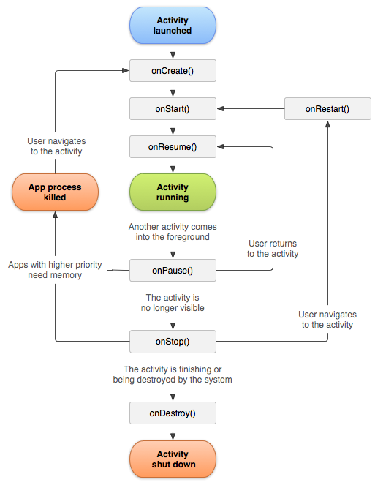

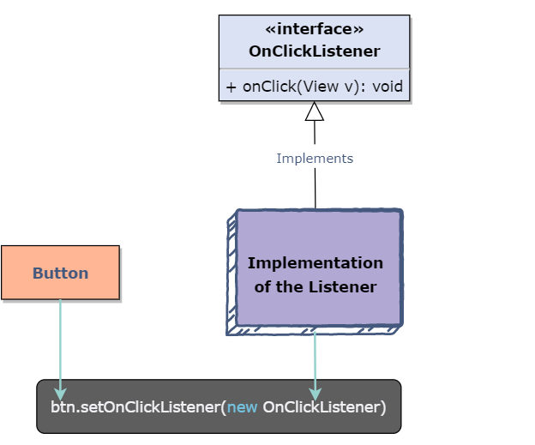

Android Developers Guide:
Activity: https://developer.android.com/guide/components/activities/intro-activities
Layouts: https://developer.android.com/guide/topics/ui/declaring-layout
Constraint layout: https://developer.android.com/training/constraint-layout

